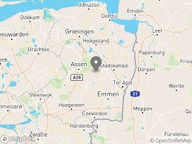
1.Klompen Museum

The museum is in Eelde ( a small village in Drenthe)

Times:
days | Opening hours
monday | closed
tuesday | 14.00-17.00
wednesday | 14.00-17.00
thursday | 14.00-17.00
friday | 14.00-17.00
saturday | 14.00-17.00
sunday | 14.00-17.00

The admission prices;
people | prices
adults | € 5,00 per person
kids | €2,50 per child
Group of 10 people | € 5,00 per person/ €2,50 per child
Group of 10 people with cake | €8,50 per person/ €6,00 per child
Group of 10 people with applecake | €11,50 per person/ €9,00 per child

The accessibility:
You can go there with the bus/train and by car. You can by walk or bike but then you are a long time for arriving.

Foods and drinks at the touristic subject:
You can eat what they provide you but you have to pay for it.

How climate-friendly is the touristic subject?
This museum isn't climate-friendly because you have to take a car or bus or train. it's 45 min with the car.

For what sub group is the touristic subject most suitable?
We don't use stars but numbers of 1 to 10.

people | number
A young couple | 5
Parents with children | 10
A middle-aged couple | 7
Senior citizens | 5
Disabled people | 0

Pictures
