Outdoor Klimpark Grolloo

- Outdoor Grolloo klimpark, klimbos Joytime

- 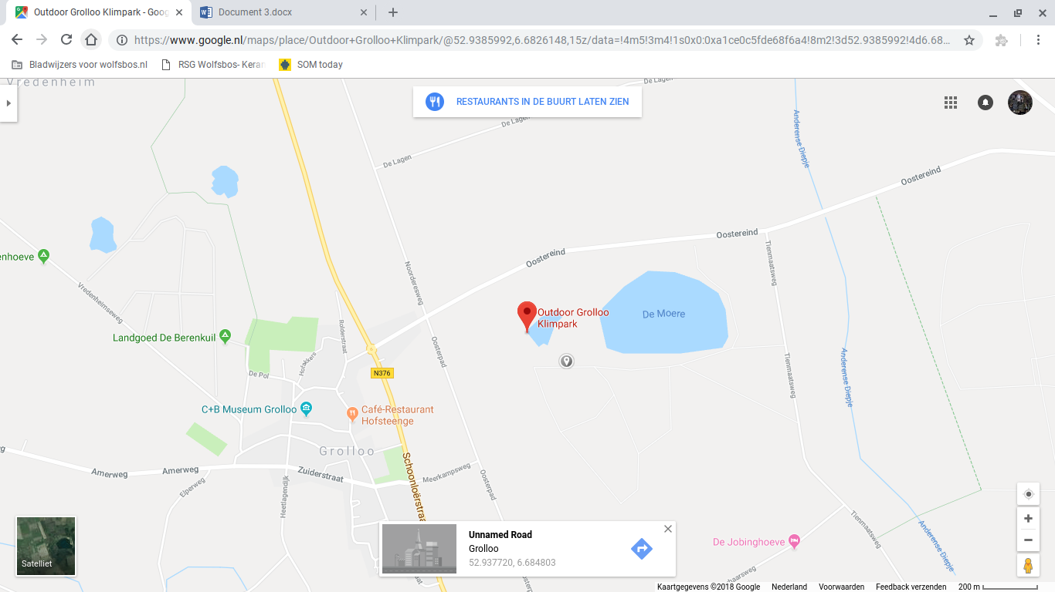
3. From March to October: 12 pm until 5 pm
From April to September: 12 pm until 6 pm, weekends: 10 am until 6 pm
4. 4 to 7 years old: free
8 to 12 years old: 15 euros
13 to 64 years old: 19 euros
65+ years old: 12,50 euros
5. by car: drive of 30 minutes from Valkenlaan 1
by bus: you have to walk a little bit; 1u 57 minutes from Valkenlaan 1 by bus
on foot: 6u 25 minutes from Valkenlaan 1
by bike: 1u and 44 minutes from Valkenlaan 1

6. You can lunch, have a barbecue or a buffet and catering for groups.
7. It is possible because it is in a forest and does not use engines
8.
 | 1 to 5 stars
Young couple | 4.5
Parents with 2 childeren | 3.5
A middle aged couple | 3
Senior citizen | 1.5
Disabled people | 1
9.
