Kamp westerbok

1-transit camp
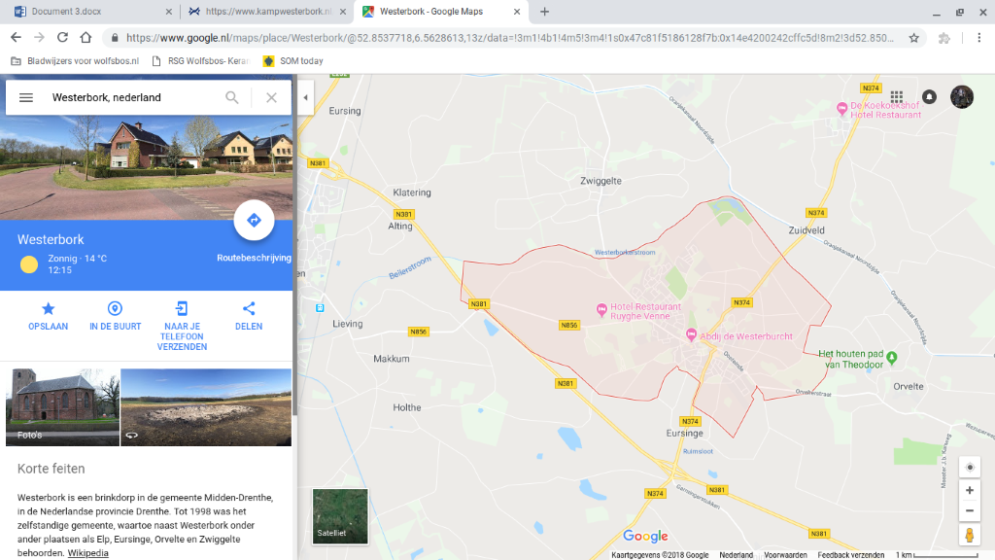 2-
Location ;drenthe
Address ;Oosthalen 8, 9414 TG Hooghalen

3-every day from 10;00 to 17;00

4- Children: free
8 tot 18 years old: € 4,00
18 and older: € 8,75
Friends: free
Veterans: free

5- by bus, by car and by foot
6-food and drinks you can take with you
7-is positive because there are not cars and buses in the park.
8-young couple 5
Parents with two young children 4
A middle –aged couple 5
Senior citzens 5
Disabled people 3

