Openluchtmuseum Ellert en Brammert.

- Addresses
Openluchtmuseum “Ellert en Brammert”
Tramstraat 73
7848 BJ SCHOONOORD
The Netherlands
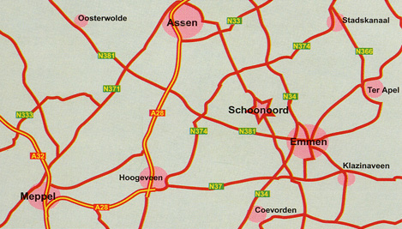

- Opening hours : Every day from 09:00 till 18:00.

- Admission 2018
Adults €8,00
Children between 4 and 11 years old €5,00
Group discount (min. 20 persons) €1,00 p.p.

- You can come to the park by bus, car, bike and walking but inside the park you can only walk.

- We offer fries, pancakes, coffee with cookies and special menu's for kids.

- We are very climate friendly, we let kids plant sunflowers and we have some gardens.
8.
 | Fitness for the people
A young couple | 3 stars
Parent with little kids | 5 stars
Middle-aged couple | 4 stars
Senior citizens | 4 stars
Disabled people | 2 stars

9.
