Kabouterland Exloo Group 3
- Name: Kabouterland Exloo
- Address: Zuiderhoofdstraat 11, 7875 BW Exloo 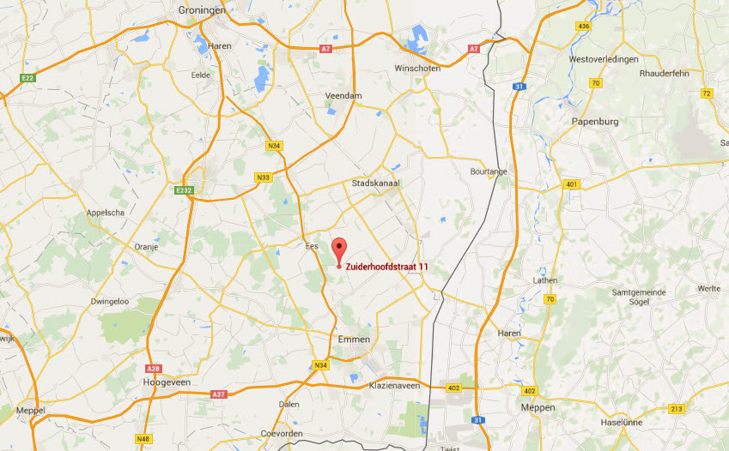
- Openingtimes: Wednesday, Saturday and Sunday from 10:00 to 17:00
- Admission prices: €8,50 per person.
- It is accessible by car or by bus and when you live close to it you can go there by bike.
- There is a restaurant called the Kabouterie, you can get fries and tosti there.
- In the winter they are closed, in the summer the park is opened because it has a outside part.

A young couple | ☆☆
Parents with 2 young children | ☆☆☆☆☆
Middle aged couple | ☆☆
Senior citizens | ☆☆
Disabled people | ☆☆☆

- 